**SQL COURSE END PROJECT 3**

### 

### Question 1

**Skills**: Coalesce, IFNULL, ISNULL

**Table:** Users

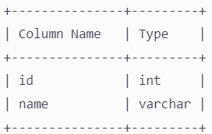

id is the primary key for this table.

name is the name of the user.

**Table**: Rides

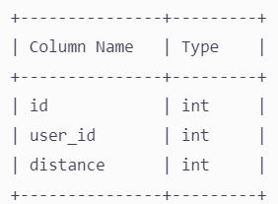

id is the primary key for this table.

city_id is the city's id who bought the product "product_name"

DB -<https://www.db-fiddle.com/f/uNZryJ1ibvBXQoTCMzKi3h/0>

**Write an SQL query to report the distance traveled by each user.**

Return the result table ordered by travelled_distance in descending order, if two or more users traveled the same distance, order them by their name in ascending order.

The query result format is in the following example.

**Users table:**

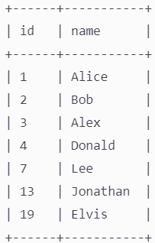

**Rides table**:

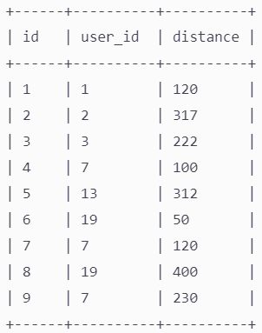

**Result table:**

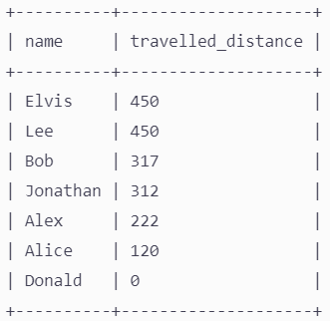

Elvis and Lee traveled 450 miles; Elvis is the top traveler as his name is alphabetically smaller than Lee's.

Bob, Jonathan, Alex, and Alice have only one ride, and we just order them by the total distance of the ride.

Donald didn't have any rides; his distance traveled was 0 **(instead of NULL)**

ANS-

Using Coalesce:

select name,Coalesce(sum(b.distance),0) as travelled_distance from Users a

left join Rides b

on a.id=b.user_id

group by 1

order by 2 desc, 1 asc;

Using IFNULL:

select name,IFNULL(sum(b.distance),0) as travelled_distance from Users a

left join Rides b

on a.id=b.user_id

group by 1

order by 2 desc, 1 asc;

Using ISNULL:

select name,case when sum(b.distance) IS Null then 0

else sum(b.distance)

end as travelled_distance

from Users a

left join Rides b

on a.id=b.user_id

group by 1

order by 2 desc, 1 asc;

### Question 2

**Skills**: Subquery in WHERE

We have a database with the name **emp**. The entire database has three tables: trainee**, projectdetails,** and **projectallocation.**

The **E.R. diagram** of the database is given below:

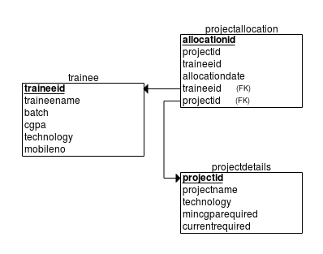

The structure of the tables is given below:

**trainee**

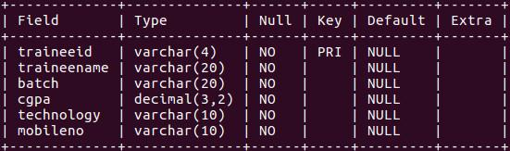

**projectdetails**

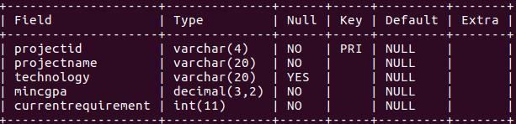

**projectallocation**

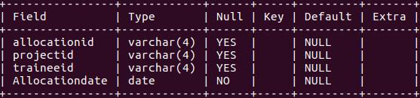

As a programmer write a SQL query to display details of all the trainee (**traineeid, traineename, cgpa** and **technology trained**) for the trainees who are eligible for **.NET** project but aren't allocated with any. Display the result in the increasing order of **traineeid**.

DB -<https://www.db-fiddle.com/f/vQepCw3A4RnpZMF3tP6rQm/0>

ANS-

select traineeid,traineename,cgpa,technology from trainee

where technology=".NET" and

traineeid not in (select traineeid from projectallocation );

### Question 3

**Skills**: WINDOWS FUNCTION (LEAD, LAG), CASE WHEN

**Print the person's name with consecutive years (twice).**

Solve the same question using WINDOWS FUNCTION and CASE-WHEN

DB -<https://www.db-fiddle.com/f/8Y61oCnyAkz64v3qFgVV4k/0>

ANS-

select * from (select Name,Year, case when Lead(Year)Over (partition by name order by Year)=year+1 then Lead(Year)Over (partition by name order by Year) else null end as "next_year" from t)a where next_year=Year+1 order by Year

Using CTE

with consecutive_year as (select Name,Year, Lead(Year) over (Partition by Name order by Year) as "next_year from t)

select Name, Year, next_year from consecutive_year where next_year=Year+1 order by Year

### Question 4

**Skills**: JOIN, String Functions - LOWER, REPLACE, SUBSTR

Use<https://www.db-fiddle.com/f/saATtNXX7L7HBJDDwVmpHW/0>

**user_profile**:

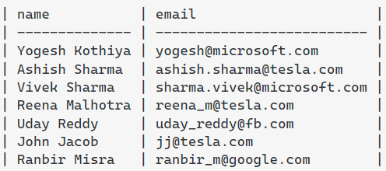

**company_profile**:

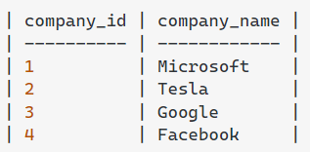

**Output Table:**

ANS-

select * from user_profile up

join company_profile cp

on Replace(substr(up.email,locate("@",up.email)+1),".com","")=lower(cp.company_name)

### 

### Question 5

**Skills**: Subquery in FROM, String Functions - LEFT, INSTR, SUBSTRING

**Solve the previous problem with alternative string functions.**

ANS-

select name,a.email,b.company_id,b.company_name from

(select name, email, replace(substr(email,(locate("@",email)+1)),".com","") as "cpy_name" from user_profile) a inner join

company_profile b

on a.cpy_name=b.company_name

### Question 6

**Skills**: SUM OVER PARTITION BY

**Instructions**: Use **imdb_movies** from the Metabase

Calculate the cumulative revenue for the year as shown below.

**Expected output:**

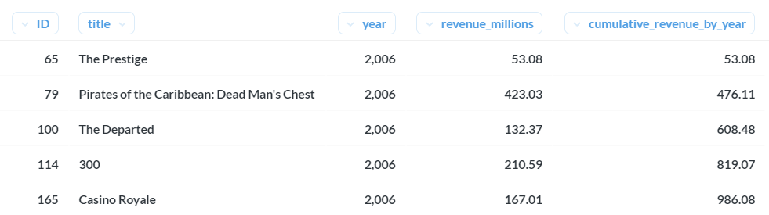

The below image shows that for each new year, i.e, 2007 sum of revenue has to start from 0

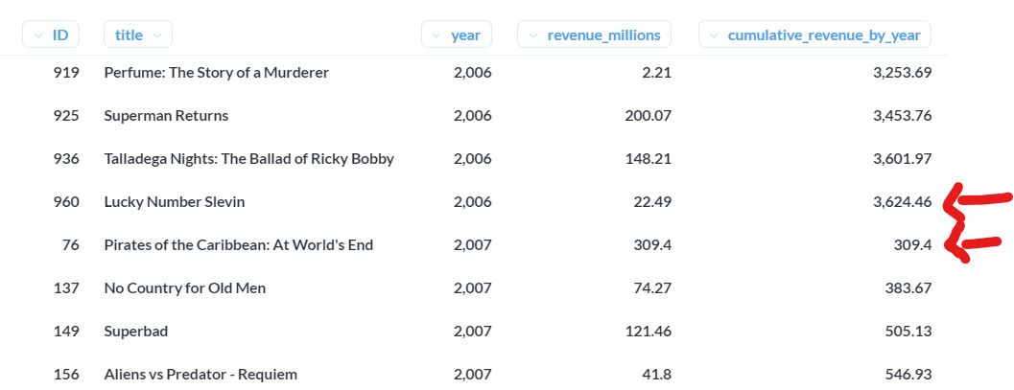

**Note**: Revenue details for some movie record needs to be included. At the same time, they are calculating cumulative revenue filters out the records where revenue is missing.

ANS-

select id,title,year,Revenue_millions,sum(Revenue_millions)over(partition by year order by id) as "cumulative_revenue_by_year"

from imdb_movies

where Revenue_millions is not null

### Question 7

Find the top 3 Products (“**productLine**”) for each month that generated the highest profit.

**Profit** = ( Price per unit - Buying Price per Unit ) x No. Of Units Ordered

**Sample Output**:

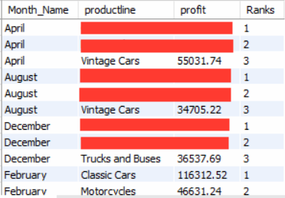

ANS-

select * from(select *,rank()over(partition by Monthname order by profit desc) as ranks from

(select Monthname(orderdate) as "Monthname",productLine,sum((priceEach-buyPrice)*quantityOrdered) as profit from cr_products p

inner join cr_orderdetails od

on p.productCode=od.productCode

inner join cr_orders o

on od.orderNumber=o.orderNumber

group by 1,2)h)k

where ranks<=3

### Question 8

**Skills**: DENSE RANK OVER PARTITION BY

Write a SQL query to get the second highest salary from the **Employee** table.

+----+--------+

| Id | Salary |

+----+--------+

| 1 | 100 |

| 2 | 200 |

| 3 | 300 |

+----+--------+

For example, given the above Employee table, the query should return 200 as the second highest salary. If there is no second-highest salary, then the query should return null.

+--------------------------------+

| SecondHighestSalary |

+--------------------------------+

| 200 |

+--------------------------------+

Use **DB Fiddle** or **MySQL workbench** to write DDL and DML commands to create TABLE and INSERT data.

ANS- To create table CREATE TABLE users ( `user_id` INTEGER, `salary` VARCHAR(5)); INSERT INTO users (`user_id`, `salary`) VALUES ('1', 100), ('2', 200), ('3', 300);

ANS from that table select * from (select user_id,salary, dense_rank()over(order by salary desc) as "ranks" from users)h where ranks=2

### Question 9

Fix Names in a Table

**Skills**: STRING Function - UPPER, LOWER, LEFT, SUBSTRING, LEFT

**Table: Users**

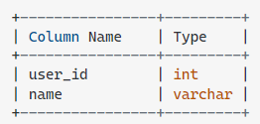

user_id is the primary key for this table.

This table contains the ID and the name of the user. The name consists of only lowercase and uppercase characters.

**Write an SQL query to fix the names so that only the first character is uppercase and the rest are lowercase.**

Return the result table ordered by user_id.

The query result format is in the following example:

**Users table:**

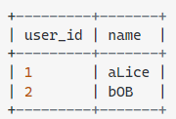

**Result table:**

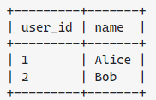

DB -<https://www.db-fiddle.com/f/v3Qq8ftURBFg1cZL4e7Vd4/0>

ANS- select user_id,concat(upper(left(name,1)),lower(substr(name,2))) as "name" from users

### 

### 

### Question 10

**Skills**: Coalesce, SUBSTRING  
**Table Person:**

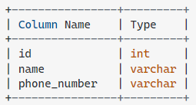

id is the primary key for this table.  
Each row of this table contains a person's name and phone number.

Phone number will be in the form 'xxx-yyyyyyy' where xxx is the country code (3 characters), and yyyyyyy is the phone number (7 characters) where x and y are digits. Both can contain leading zeros.

**Table Country:**

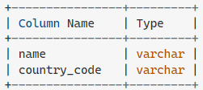

country_code is the primary key for this table.

Each row of this table contains the country name and its code. country_code will be in the form 'xxx' where x is digits.

**Person table:**

+----+----------+--------------+

| id | name | phone_number |

+----+----------+--------------+

| 3 | Jonathan | 051-1234567 |

| 12 | Elvis | 051-7654321 |

| 1 | Moncef | 212-1234567 |

| 2 | Maroua | 212-6523651 |

| 7 | Meir | 972-1234567 |

| 9 | Rachel | 972-0011100 |

+----+----------+--------------+

**Country table:**

+----------+--------------+

| name | country_code |

+----------+--------------+

| Peru | 051 |

| Israel | 972 |

| Morocco | 212 |

| Germany | 049 |

| Ethiopia | 251 |

+----------+--------------+

Write an SQL query to get the following table,

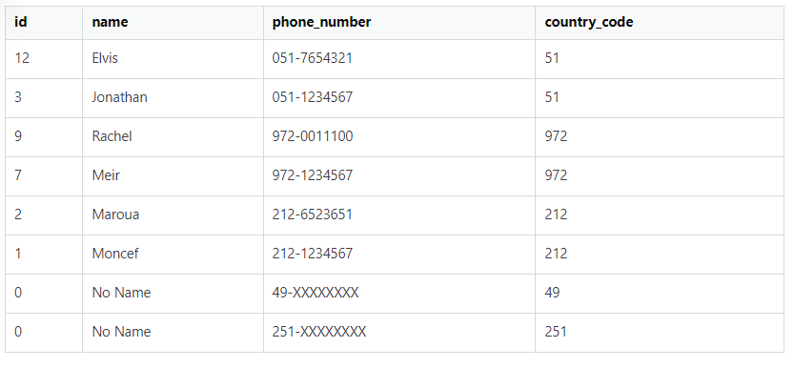DB -<https://www.db-fiddle.com/f/eRQeiaYJRpaMjW9HKLLg4V/0>

ANS-

select Coalesce(b.id,0), Coalesce(b.name,"NoName"),

Coalesce(b.phone_number,concat_ws("-",a.country_code,"XXXXXXX")), a.country_code from country a

left join person b

on substr(b.phone_number,1,3)=a.country_code

### 

### Question 11

Filter the ‘In Process’ orders and replace the missing comments with ‘Status yet to be updated with the comment’

Use “**Car Retailer**” dataset

**Instructions**: Use COALESCE or IFNULL to solve the problem

**Skills**: COALESCE or IFNULL

ANS- select *,coalesce(comments,"Status yet to be updated with the comment") from cr_orders where Status="in process"

### Question 12

Print the address of the customer as follows,

**Format:** *addressLine1, {state}, city {- postcode}, country  
addressLine1 followed by the state if present, followed by postal code if present else city, and followed by the country.*

Use “**Car Retailer**” dataset

**Instructions**: Use COALESCE or IFNULL to solve the problem

**Skills**: COALESCE or IFNULL and CONCAT and CONCAT_WS

ANS- select concat_ws("",contactFirstName,contactLastName) as "fullName", customername, addressLine1, state, postalCode, city, country, concat(addressLine1,ifnull(concat(",",state),""), ifnull(concat("-",postalCode),concat(",",city)),",",country) as full_address from cr_customers

### 

### 

### Question 13

Use “**Car Retailer**” dataset  
Find the Month on Month growth in profit for each year.  
MoM_growth is calculated as follows.

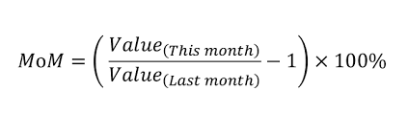

For example,

MoM (Feb 2003) = ((Annual Revenue of Feb 2003/Annual Revenue of Jan 2003) - 1) * 100

**Note**: Please make sure that MoM is calculated for each year. Ideally, the MoM growth of the first month of every year should be NULL, as shown in the sample output below.

**Output**:

*Only the first three and last months are shown for each year. This is the sample output. You must have all the year's months in the final output.*

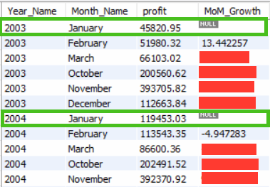

ANS

select *,((profit/lag(profit)over(partition by yr order by month_no)-1)*100) as MOM from

(select year(o.orderdate) as yr,Monthname(o.orderdate) as month, month(orderdate) as "month_no", sum((priceEach-buyPrice)*quantityOrdered) as profit from cr_orders o

inner join cr_orderdetails od

on o.orderNumber=od.orderNumber

inner join cr_products p

on od.productCode=p.productCode

group by 1,2,3)k

### Question 14

3 points possible (graded)

### Use “**Car Retailer**” dataset

### For each customer i.e (customerNumber) count the number of orders above and below the average order value.

### **“Average Order Value(AOV)”** is calculated as below,

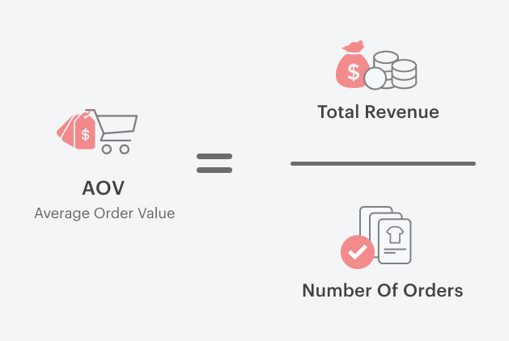

**Total Revenue** is calculated as the sum of the revenue of each order.

Each order revenue is **Price per unit * No. Of Units**.

**Open Hint**: AVG() OVER() Windows Function can be used here to calculate AOV.

Since you need to get the count of orders above and below the AOV, the final output looks like the one below.

Conditions to get the following details,

**Order Above AVG** = Actual Order Value **>=** AVG Order Value

**Order Below AVG** = Actual Order Value **<** AVG Order Value

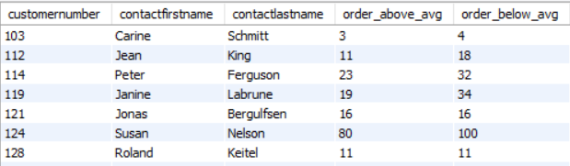

What is the Average Order Value? Submit the value in the answer.

**Note**: Round off the value to 2 decimal and use it for the rest of the calculation.

ANS- with cte as (select c.customerNumber,c.contactFirstName,c.contactLastName,(od.priceEach*od.quantityOrdered) as orderwiseavg, round(avg(od.priceEach*od.quantityOrdered) over(),2) as AVO from cr_orderdetails od join cr_orders o on od.orderNumber=o.orderNumber join cr_customers c on o.customerNumber=c.customerNumber )

select customerNumber,contactFirstName,contactLastName,

count(case when orderwiseavg>=AVO THEN 1 END) AS Orders_above_avg, count(case when orderwiseavg<=AVO then 1 end) as Orders_below_avg from cte group by 1,2,3 order by 1

### Question 15 1/1 point (graded) Use “**Car Retailer**” dataset In the business, customer order the product in bulk, and it is the utmost priority of the business to fulfill the order requirement as to when required. Hence, a business must keep checking their stock regularly to deliver uninterrupted. To make that happen, create a report as shown below to get the updated stock and status to check if we are running out of stock (or are we going to fulfill the next customer order?)

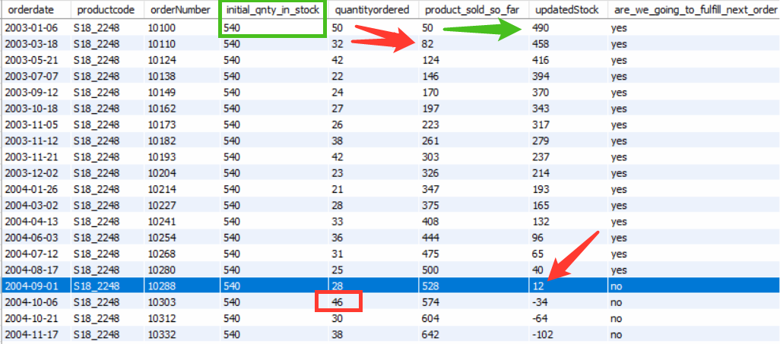

Consider the first row as an example where product code “**S18_2248**”. Its initial stock quantity was **540**. After the first order i.e. ordernumber 10100 from the customer i.e. **order quantity of 50,** the updated stock value would be (540 - 50) 490. Now, the status needs to be updated based on the next order quantity, for example, the Next order is of quantity 32, and we have 490 products in stock hence we can easily serve the next order request (Status is **Yes**)  
But if you look at the blue highlighted row then, in that case, “updatedStock” value is 12, and next order is of quantity 46 hence the status would **No**. Select the list of productCodes that will be getting out of Stock (i.e, “are_we_going_to_fulfill_next_order” value is **No**)

ANS-

select distinct(productCode),are_we_going_to_fulfill_next from (select *,case when updated_stock>lead(quantityOrdered)over() then "yes" else "no" end as "are_we_going_to_fulfill_next" from (select *,(quantityInStock-product_sold_so_far) as updated_stock from (select orderdate, o.orderNumber, p.productCode, (quantityInStock), quantityOrdered, sum(quantityOrdered)over (partition by productCode order by orderdate) as product_sold_so_far from cr_orders o inner join cr_orderdetails od on o.orderNumber=od.orderNumber inner join cr_products p on p.productCode=od.productCode group by 1,2,3)k)l)m where are_we_going_to_fulfill_next="no"

### Question 16 Use “**Car Retailer**” dataset Find all products whose quantity exceeds the average quantities of all product categories.

**How to get the product category?** Split the **productCode** by “**_”** and take the left part of it. For example, **S700_3962** will result in the **S700** product category.

**Skills**: ALL, String Functions

ANS- select * from cr_products where quantityInStock>all(select avg(quantityInStock) from (select quantityInStock, left(productCode,instr(productCode,"_")-1) as"product_category" from cr_products)k group by product_category)